SST309-04, Geo-Diary Brochure
Gina Groover

Home

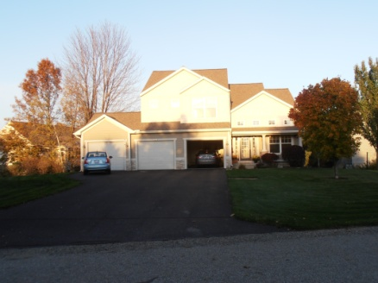
6:27 PM Sunday, October 21, East
My home is located about 5 miles northwest of Holland in Park Township. We have beaches, nature trails, and bike paths nearby. I can ride my bike to Lake Michigan. (Relative location; Physical Characteristics of Place)

Big Red Lighthouse

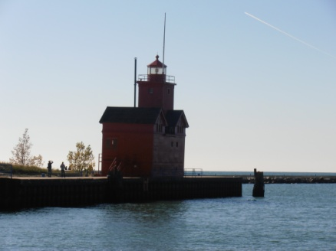
3:26 PM Sunday, October 21, Southwest
I spend a lot of time at Holland State Park with my children; fishing, swimming, and watching boats pass through the channel. This photo was taken from the walkway on the north side of the channel…the perfect spot to view Big Red. (Human-Environment Interaction; Great Lakes Region, Movement of People and Goods)
Work

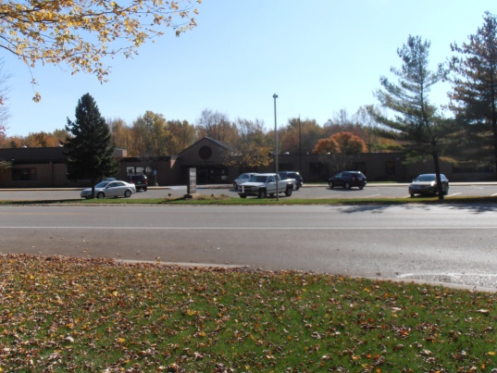
2:38 PM Sunday, October 21, South
I work at Waukazoo Elementary, located at 1294 W. Lakewood Blvd. This is the front of the school, which faces north. We use the woods on the south side of the school for nature studies with our students. (Absolute location; Physical Characteristics of Place)

Time for Groceries

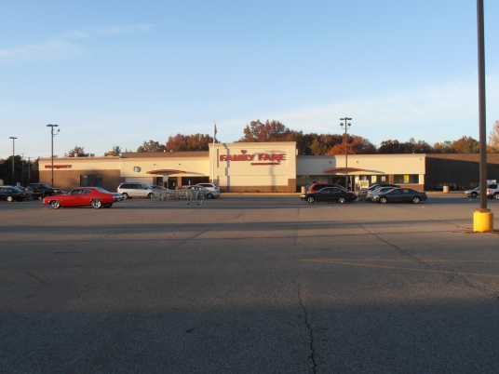
6:18 PM, Sunday, October 21, North
I buy my groceries at the Family Fare on Butternut Dr. The store’s close proximity to my home (about 3 miles) makes it a convenient place to shop. (Absolute location; Relative location; Movement of Goods)
Herrick District Library

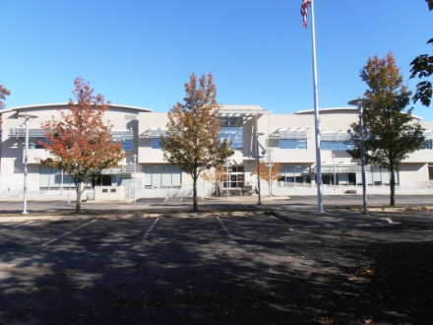
3:46 PM, Sunday, October 12, East
Herrick District Library on River Ave. is where my family goes to find books for school and for pleasure. This photo was taken from the parking lot on the west side of the library. (Absolute location; Movement of goods and services)

Downtown Holland

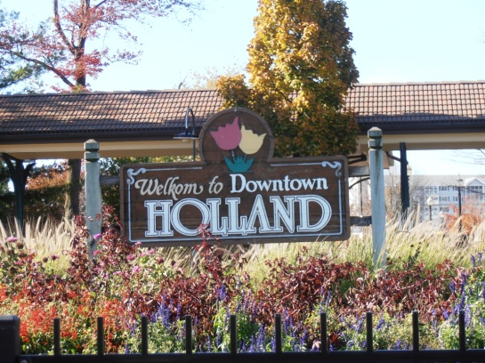
3:54 PM, Sunday, October 21, Northwest
This sign on the east side of the Amtrak train station welcomes visitors to Holland and features the tulips Holland is known for. Each May we hold a Tulip Time Festival to celebrate Holland’s Dutch heritage. (Physical characteristics of Place; Human-Environment Interaction; Movement of People)

Places Near Holland

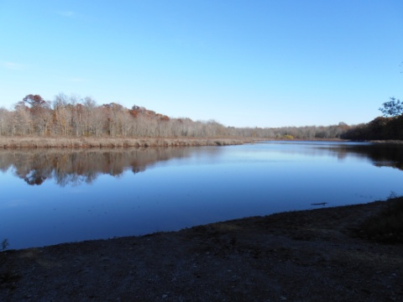
4:28 PM, Sunday, October 21, East
Gilligan Lake is located about 5 miles from Saugatuck, MI, in Laketown Township. My sons and I like to fish there and explore the nearby woods. (Human-Environment Interaction; Place; Relative Location)

Felt Mansion

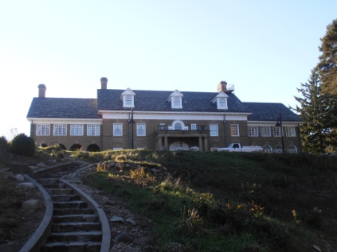
5:23 PM, Sunday, October 21, West
The Felt Mansion lies between Holland and Saugatuck. My son is fascinated by rumors that it is haunted. We like to tour the mansion and explore the surrounding woods. We haven’t seen a ghost yet, but we hope to! (Relative Location; Human-Environment Interaction)

Crane’s Orchard

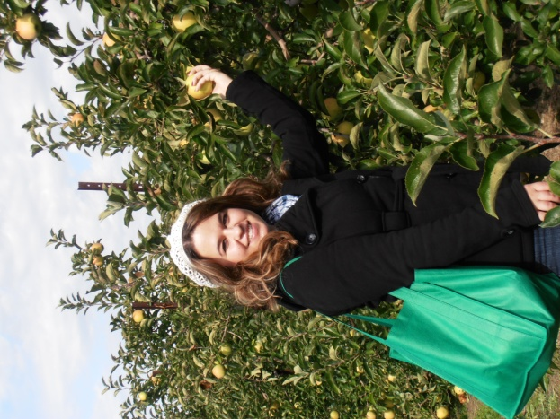
3:04 PM, Sunday, October 2, 2011, East
Crane’s Orchard in Fennville, MI, is part of
Michigan’s 10 million acres of farmland.
My college-aged daughter enjoys going to
pick apples with me. As part of the Great
Lakes region, we are fortunate to have a
plentiful supply of fresh water for farming.
(Physical and Human Characteristics
of Place; Relative Location; Human-
Environment Interaction; Region)

Places Far Away –Venice, FL

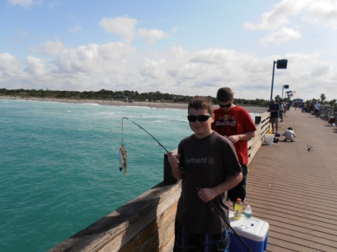
10:38 AM, Sunday April 1, Northeast
Each year, my family travels to Venice, FL, to enjoy the Gulf of Mexico. Venice is the shark tooth capital of the world. We have found dozens of fossilized shark’s teeth. Fishing off the Venice Pier is always part of our trip. (Physical Characteristics of Place; Human-Environment Interaction)

Niagara Falls, Canada

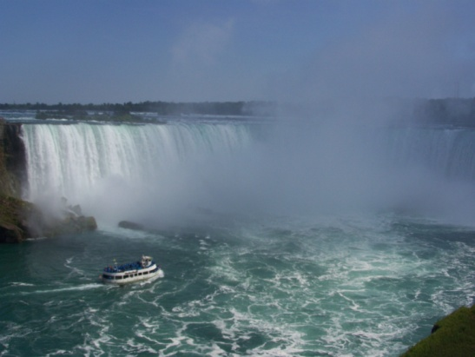
3:18 PM, Thursday, July 21, 2011, Southeast
On the way to visit relatives in Rochester, NY, we stopped to see Niagara’s Horseshoe Falls. We viewed them from the Canadian side, which is in Niagara Falls, Ontario, Canada. (Physical Characteristics of Place; Location; Human-Environment Interaction; Movement of People)

